TROUBLESHOOTING NETWORK SERVICES PRACTICE
- Simulate a DNS resolution failure on your local machine by editing the hosts file to point www.spotify.com to a wrong IP address, then try to ping the domain and document the error message you receive.
Answer
DNS Resolution Failure
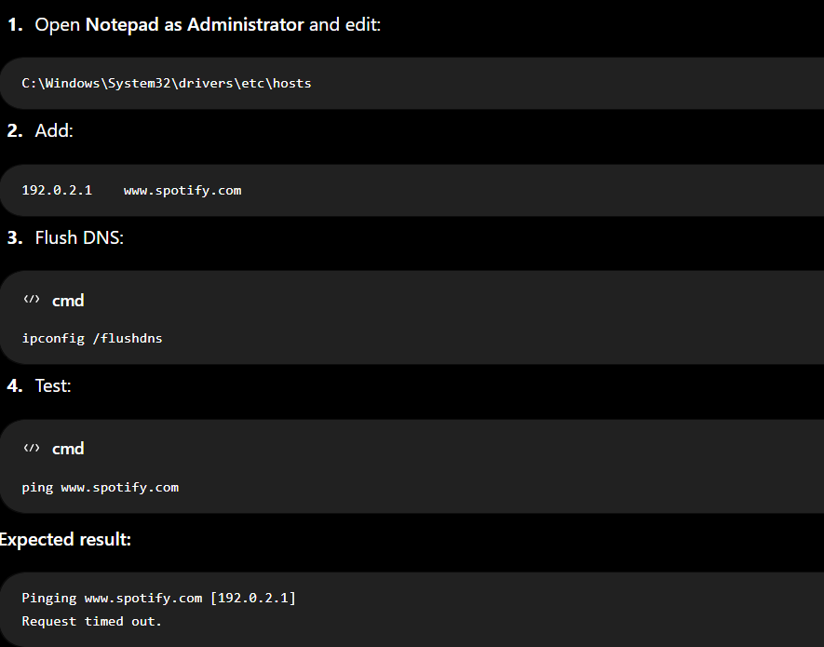
Reason: The hosts file forces the domain to the wrong IP address, so the ping cannot reach the real Spotify server.
- Configure a DHCP server in a network simulator (such as Cisco Packet Tracer or GNS3) and intentionally set an incorrect default gateway; connect a client device and verify the assigned gateway, then describe how you would identify and fix this issue.
Answer
Step 1: Simulating the Misconfiguration in Cisco Packet Tracer
- Topology Setup:
  - Place a Generic Server (DHCP_Server) and a PC (PC0) on the workspace.
  - Connect both devices using a Copper Straight-Through cable (or via a Switch).
- Server IP Configuration:
  - Select DHCP_Server > Desktop > IP Configuration.
  - Set Static IP Address: 192.168.1.2
  - Set Subnet Mask: 255.255.255.0
- DHCP Pool Misconfiguration:
  - Go to DHCP_Server > Services tab > DHCP.
  - Ensure Service is set to On.
  - Intentionally set an incorrect Default Gateway: Set Default Gateway to 10.0.0.1 (which is outside the local subnet 192.168.1.0/24).
  - Set Start IP Address: 192.168.1.100
  - Set Subnet Mask: 255.255.255.0
  - Click Save.
- Request IP on Client Device:
  - Select PC0 > Desktop > IP Configuration.
  - Switch the radio button from Static to DHCP.
Step 2: Verifying the Assigned Settings on the Client
On PC0, check the received IP settings in the IP Configuration window or by opening the Command Prompt and running:
DOS
ipconfig /all
Verification Result:
- IP Address: 192.168.1.100
- Subnet Mask: 255.255.255.0
- Default Gateway: 10.0.0.1 (Incorrect)
While local network communication (such as pinging the DHCP server at 192.168.1.2) works, any attempt to ping an external network address (e.g., ping 8.8.8.8) fails because the gateway 10.0.0.1 is unreachable on the local link.
Step 3: Identification & Resolution Process
How to Identify the Issue:
- Symptom Analysis: The client device can communicate with local devices on 192.168.1.0/24, but cannot reach external networks or the internet.
- Command Diagnostics:
  - Run ipconfig on the client. Notice that the Default Gateway (10.0.0.1) does not belong to the local IP subnet (192.168.1.0/24).
  - Run ping 10.0.0.1 on the client. The request times out, confirming the gateway is unreachable.
How to Fix the Issue:
- Correct the DHCP Server Settings:
  - Open DHCP_Server > Services > DHCP.
  - Update the Default Gateway to the correct router interface IP (e.g., 192.168.1.1).
  - Click Save.
- Refresh Client Lease:
  - Go to PC0 > Command Prompt and release/renew the DHCP lease:
DOS
ipconfig /release
ipconfig /renew
- Verify Resolution: Run ipconfig again on PC0 to confirm the Default Gateway now displays 192.168.1.1. Test connectivity by pinging the gateway (ping 192.168.1.1).

- Given a scenario where devices on your simulated network are unable to access websites by name but can by IP address, use the nslookup or dig tool to diagnose the DNS problem and write down the troubleshooting steps and solution.
Answer
DNS Troubleshooting Scenario
Problem: Websites work using their IP address, but not by domain name. This indicates a DNS problem.
Troubleshooting Steps
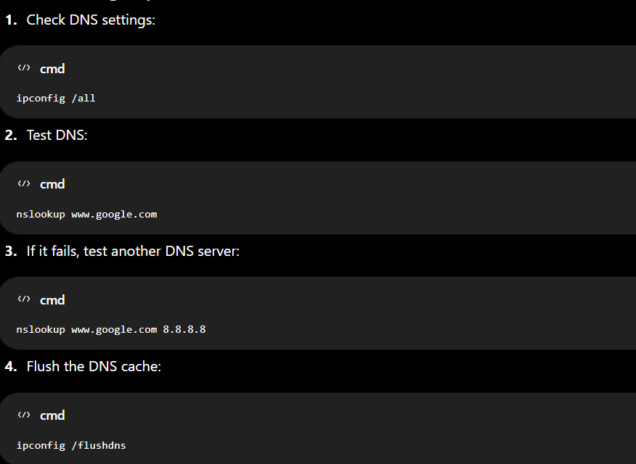
- Check that the network/DHCP configuration provides a correct DNS server.
Solution
Set a working DNS server, such as 8.8.8.8, in the device or DHCP configuration, then flush the DNS cache and test again.
Result: The device should be able to access websites using their domain names.
- A device in your simulated network is not receiving an IP address from the DHCP server and shows an APIPA address (169.x.x.x). List the possible causes for this and document the step-by-step process you would use to resolve it. Check for network connectivity, DHCP scope exhaustion, and server availability.

Answer
Resolving APIPA (169.254.x.x) Issues
Primary Causes: Physical link failure, DHCP service offline, scope exhaustion, or missing DHCP relay (ip helper-address).
Resolution Steps:
- Physical Link: Verify the network cable and switch port are active.
- Server Service: Ensure the DHCP service is running on the server.
- Pool Capacity: Check and expand the DHCP IP pool range if exhausted.
- DHCP Relay: Configure ip helper-address <DHCP_IP> on the gateway if on a different subnet.
- Renew Lease: Run ipconfig /renew (Windows) or sudo dhclient (Linux) to obtain a valid IP address.

- Create a table documenting at least three common DNS issues and three common DHCP issues you encountered or researched, including symptoms, possible causes, and recommended solutions for each.
Answer
